**• Determine the purpose of database**

create a database management system to manage the prescription, inventory, employee, and other data for pharmacy Aragon.

**• Determine the Entities**

tblClinic,

tblDoctor,

tblClass,

tblEmployee,

tblEmployeeTraining,

tblJobtitle,

tblDrug,

tblRefill,

tblRx,

tblCustomer,

tblHealthPlan,

tblHousehold

**• Determine the attributes in each entity**

tblClinic

ClinicID (PK), Clinic Name, Address1, Address2, City, Province, Postalcode, Phone

tblDoctor

DoctorID(PK), DoctorFirst, DoctorLast, Phone, Cell, ClinicID

tblClass

ClassID(PK), Description, Cost, Renewal, Required , Provider

tblEmployee

EmpID, EmpFirst, EmpMI, EmpLast, SINs, DOB, StartDate, EndDate, Address, City, Province,

PostalCode, JobID, Memo, Phone, Cell, Salary, HourlyRate, Review

tblEmployeeTraining

EmpID, Date, ClassID

tblJobtitle

JobID, Title

tblDrug

DIN, Name, Generic, Description, Unit, Dosage, DosageForm, Cost, Price, Interactions,

Supplier

tblRefill

PrescriptionID, RefillDate, EmpID

tblRx

PrescriptionID (PK), DIN(FK), Quantity, Unit, Date, ExpireDate, Refills, AutoRefill, RefillsUsed, Instructions, CustID (FK), DoctorID (FK)

tblCustomer

CustID, CustFirst, CustLast, Phone, DOB, Gender, Balance, ChildproofCap, PlanID, HouseID,

HeadHH, Allergies

tblHealthPlan

PlanID, PlanName, Address, City, Province, PostalCode, Phone, Days, WebSite

tblHousehold

HouseID, Address, City, Province, PostalCode

**• Create the Data dictionary**

|  |  |  |  |  |
| --- | --- | --- | --- | --- |
| Entity Name | AttributeName | Data type | Required | key : PK FK |
| tblCustomer |  |  |  |  |
|  | CustID | nchar(5) | yes | pk |
|  | CustFirst | nvarchar(30) | yes |  |
|  | CustLast | nvarchar(30) | yes |  |
|  | Phone | nvarchar(15) | yes |  |
|  | DOB | datetime | yes |  |
|  | Gender | nvarchar(10) | yes |  |
|  | Balance | nvarchar(20) | yes |  |
|  | ChildproofCap | bit | yes |  |
|  | PlanID | nvarchar(50) | yes | fk |
|  | HouseID | nvarchar(30 | yes | fk |
|  | HeadHH | nvarchar(20) | no |  |
|  | Allergies | nvarchar(50) | yes |  |
|  |  |  |  |  |
|  |  |  |  |  |
| tblHealthPlan |  |  |  |  |
|  | PlanID | nvarchar(50) | yes | pk |
|  | PlanName | nvarchar(50) | yes |  |
|  | Address | nvarchar(30) | yes |  |
|  | City | nvarchar(20) | yes |  |
|  | Province | nchar(2) | yes |  |
|  | PostalCode | nchar(7) | yes |  |
|  | Phone | nvarchar(15) | yes |  |
|  | Days | tinyint | yes |  |
|  | WebSite | nvarchar(50) | yes |  |
|  |  |  |  |  |
|  |  |  |  |  |
| tblHousehold |  |  |  |  |
|  | HouseID | nvarchar(30) | yes | pk |
|  | Address | nvarchar(30) | yes |  |
|  | City | nvarchar(20) | yes |  |
|  | Province | nvarchar(2) | yes |  |
|  | PostalCode | nvarchar(7) | yes |  |
|  |  |  |  |  |
| tblEmployee |  |  |  |  |
|  | EmpID | smallint | yes | pk |
|  | EmpFirst | nvarchar(30) | yes |  |
|  | EmpMI | nchar(2) | yes |  |
|  | EmpLast | nvarchar(30) | yes |  |
|  | SINs | nchar(11) | yes |  |
|  | DOB | date | yes |  |
|  | StartDate | date | yes |  |
|  | EndDate | date | yes |  |
|  | Address | nvarchar(30) | yes |  |
|  | City | nvarchar(20) | yes |  |
|  | Province | nchar(2) | yes |  |
|  | PostalCode | nchar(7) | yes |  |
|  | JobID | smallint | yes | fk |
|  | Memo | nvarchar(255) | yes |  |
|  | Phone | nvarchar(15) | yes |  |
|  | Cell | nvarchar(15) | yes |  |
|  | Salary | varchar(30) | yes |  |
|  | HourlyRate | decimal(2) | yes |  |
|  | Review | date | no |  |
|  |  |  |  |  |
|  |  |  |  |  |
| tblEmployeeTraining |  |  |  |  |
|  | EmpID | smallint | yes | fk |
|  | Date | date | no |  |
|  | ClassID | smallint | yes | fk |
|  |  |  |  |  |
| tblClass |  |  |  |  |
|  | ClassID | smallint | yes | pk |
|  | Description | nvarchar(100) | yes |  |
|  | Cost | money | yes |  |
|  | Renewal | bit | yes |  |
|  | Required | bit | yes |  |
|  | Provider | nvarchar(20) | no |  |
|  |  |  |  |  |
| tblJobtitle |  |  |  |  |
|  | JobID | smallint | yes | pk |
|  | Title | nvarchar(30) | yes |  |
|  |  |  |  |  |
| tblRx |  |  |  |  |
|  | PrescriptionID | nvarchar(20) | yes | pk |
|  | DIN | smallint | yes | fk |
|  | Quantity | decimal | yes |  |
|  | Unit | nvarchar(10) | yes |  |
|  | Date | date | yes |  |
|  | ExpireDate | date | yes |  |
|  | Refills | tinyint | yes |  |
|  | AutoRefill | bit | yes |  |
|  | RefillsUsed | smallint | no |  |
|  | Instructions | nvarchar(50) | yes |  |
|  | CustID | nchar(5) | yes | fk |
|  | DoctorID | smallint | yes | fk |
|  |  |  |  |  |
| tblRefill |  |  |  |  |
|  | PrescriptionID | nvarchar(20) | yes | fk |
|  | RefillDate | date | no |  |
|  | EmpID | smallint | yes | fk |
|  |  |  |  |  |
|  |  |  |  |  |
| tblDrug |  |  |  |  |
|  | DIN | smallint | yes | pk |
|  | Name | nvarchar(30) | yes |  |
|  | Generic | bit | yes |  |
|  | Description | nvarchar(100) | yes |  |
|  | Unit | nchar(10) | yes |  |
|  | Dosage | nchar(10) | yes |  |
|  | DosageForm | nvarchar(20) | yes |  |
|  | Cost | money | yes |  |
|  | Price | money | yes |  |
|  | Interactions | nvarchar(50) | yes |  |
|  | Supplier | nvarchar(20) | yes |  |
|  |  |  |  |  |
| tblDoctor |  |  |  |  |
|  | DoctorID | smallint | yes | pk |
|  | DoctorFirst | nvarchar(30) | yes |  |
|  | DoctorLast | nvarchar(30) | yes |  |
|  | Phone | nvarchar(15) | yes |  |
|  | Cell | nvarchar(15) | yes |  |
|  | ClinicID | nvarchar(20) | yes |  |
|  |  |  |  |  |
| tblClinic |  |  |  |  |
|  | ClinicID | nvarchar(20) | yes | pk |
|  | ClinicName | nvarchar(50) | yes |  |
|  | Address1 | nvarchar(40) | yes |  |
|  | Address2 | nvarchar(40) | yes |  |
|  | City | nvarchar(20) | yes |  |
|  | Province | nchar(2) | yes |  |
|  | Postalcode | nchar(7) | yes |  |
|  | Phone | nvarchar(15) | yes |  |

**• Determine the relationships by creating the Entity relationship Diagram(ERD)**

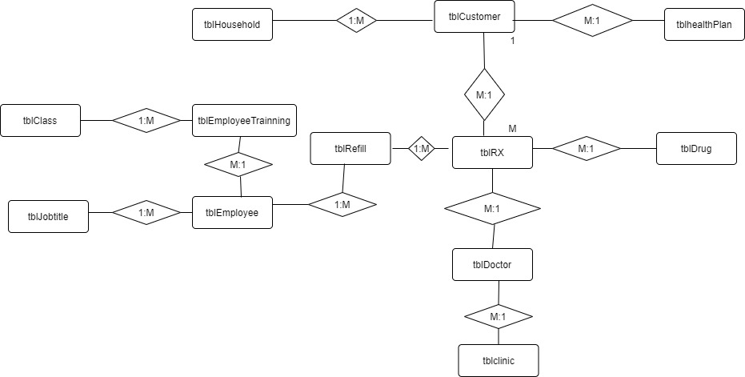

**• Transfer the ERD into a relational system**

